Research Question

A. Summarize the real-data research question you identified in Task 1. Your summary should include justification for the research question you identified in Task 1, a description of the context in which the research question exists, and a discussion of your hypothesis.
Summary:
The research question for this project is: Can a patient's demographic and health-related attributes (such as age, gender, blood pressure, and heart rate) be used to predict the risk of a heart attack?
This question is justified by the high prevalence and mortality rate of heart disease globally. Early identification of at-risk individuals can enable timely intervention and prevention, potentially saving lives and optimizing healthcare resources.
Context:
Heart disease is a leading cause of death worldwide. Hospitals and clinicians often have access to basic demographic and health indicators for patients. Leveraging these data points with machine learning can help identify patterns and predictors of heart attack risk, supporting clinical decision-making.
Hypothesis:
Null Hypothesis: There is no statistically significant relationship between a patient's health indicators and the likelihood of a heart attack.
Alternative Hypothesis: There is a statistically significant relationship between a patient's health indicators and the likelihood of a heart attack.
Data Collection

B. Report on your data-collection process by describing the relevant data you collected, discussing one advantage and one disadvantage of the data-gathering methodology you used, and discussing how you overcame any challenges you encountered during the process of collecting your data.
The dataset used is the "Heart Attack Dataset - Tarik A. Rashid" from Kaggle, containing patient records from Zheen Hospital in Erbil, Iraq (Jan–May 2019). It includes attributes such as age, gender, heart rate, blood pressure, blood sugar, CK-MB, troponin, and heart attack diagnosis. Using an existing, publicly available dataset saves time and ensures data is already cleaned and anonymized for research. The dataset may not be fully representative of other populations or regions, which could limit the generalizability of the findings. A challenge was ensuring the dataset was complete and free of errors. I overcame this by thoroughly inspecting the data for missing values, duplicates, and outliers, and applying appropriate preprocessing steps.
Data Extraction and Preparation
C. Describe your data-extraction and data-preparation process, and provide screenshots to illustrate each step. Explain the tools and techniques you used for data extraction and data preparation, including how these tools and techniques were used on the data. Justify why you used these particular tools and techniques, including one advantage and one disadvantage when they are used with your data-extraction and data-preparation methods.
The feature correlation matrix provides a visual summary of the linear relationships between all pairs of variables in the dataset, including the target variable (Result). Each cell in the matrix shows the correlation coefficient between two features, ranging from -1 (perfect negative correlation) to +1 (perfect positive correlation).
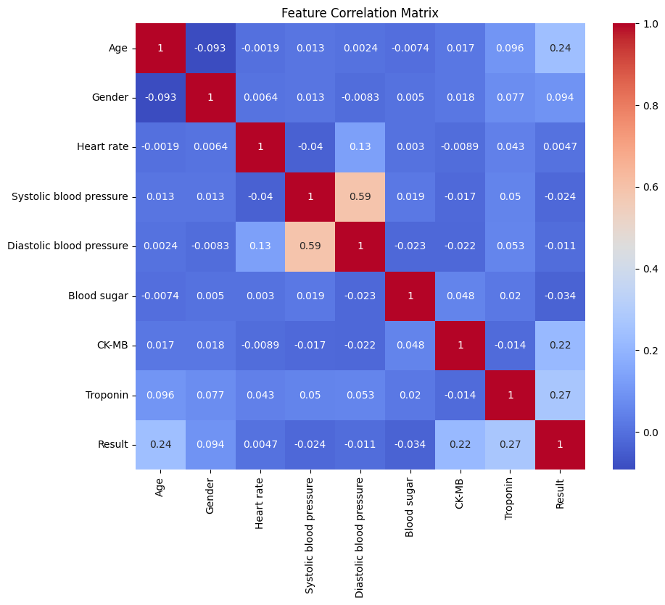
Key observations from the matrix:

Troponin and Result:
The correlation between Troponin and Result is 0.27, indicating a moderate positive relationship. This suggests that higher troponin levels are associated with a higher likelihood of a positive heart attack diagnosis, which aligns with clinical expectations.

CK-MB and Result:
The correlation between CK-MB and Result is 0.22, also a moderate positive correlation. CK-MB is another cardiac marker, and its positive association with heart attack diagnosis is clinically relevant.

Age and Result The correlation between Age and Result is 0.24, suggesting that older age is somewhat associated with a higher risk of heart attack.
Blood Pressure:
Systolic blood pressure and Diastolic blood pressure are strongly correlated with each other (0.59), as expected, but show weak or negligible correlation with the target variable.
Limitations:
Features with higher correlation to the target (Troponin, CK-MB, Age) are likely to be more important for prediction and may be prioritized in feature selection or model interpretation.
Strong correlations between features (e.g., between systolic and diastolic blood pressure) may indicate multicollinearity, which can affect some models (like logistic regression) and should be considered during analysis.

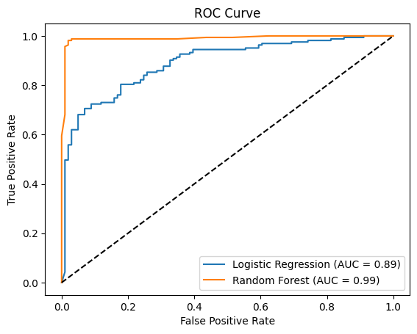
Logistic Regression is interpretable, allowing us to understand the influence of each predictor on heart attack risk.
Advantage: Easy to interpret and explain to clinicians.
Disadvantage: May underperform if relationships are non-linear.
Random Forest can capture complex interactions and typically yields higher accuracy.
Advantage: High predictive power and robustness to overfitting.
Disadvantage: Less interpretable than logistic regression.
Analysis
D. Report on your data analysis process by describing the analysis technique(s) you used to appropriately analyze the data. Include the calculations you performed and their outputs. Justify how you selected the analysis technique(s) you used, including one advantage and one disadvantage of each technique.
Step 1: Loading the Data
I began by loading the medical dataset from a CSV file into a DataFrame using pandas. This allowed me to easily view and manipulate the data for analysis.
Output:
The dataset contains 1,319 rows and 9 columns, including patient age, gender, heart rate, blood pressure, blood sugar, CK-MB, Troponin, and the result (positive/negative for heart attack).
Step 2: Checking for Missing Values and Duplicates
I checked for missing values in each column and for duplicate records to ensure data quality.
Output:
There were no missing values and no duplicate records in the dataset, so no rows needed to be removed for these reasons.
Step 3: Imputing Missing Values (if any)
Although there were no missing values in this dataset, the code is set up to handle them by filling in missing numeric values with the mean and categorical values with the most frequent value. This ensures that if missing data were present, it would not disrupt the analysis.

Step 4: Handling Outliers
To reduce the impact of extreme values (outliers), I capped all numeric features at the 1st and 99th percentiles. This helps prevent unusual data points from skewing the analysis.
Step 5: Normalizing the Data
All numeric features were normalized using StandardScaler, which transforms each feature to have a mean of 0 and a standard deviation of 1. This step ensures that all features are on the same scale, which is important for many machine learning algorithms.
Output Example:
Step 6: Understanding the Data
After cleaning, I printed the first few rows, the shape, and the column names to confirm the data was ready for analysis.
The columns are:
Age, Gender, Heart rate, Systolic blood pressure, Diastolic blood pressure, Blood sugar, CK-MB, Troponin, and Result.
The Result column contains two values: 'negative' and 'positive', indicating whether the patient had a heart attack.
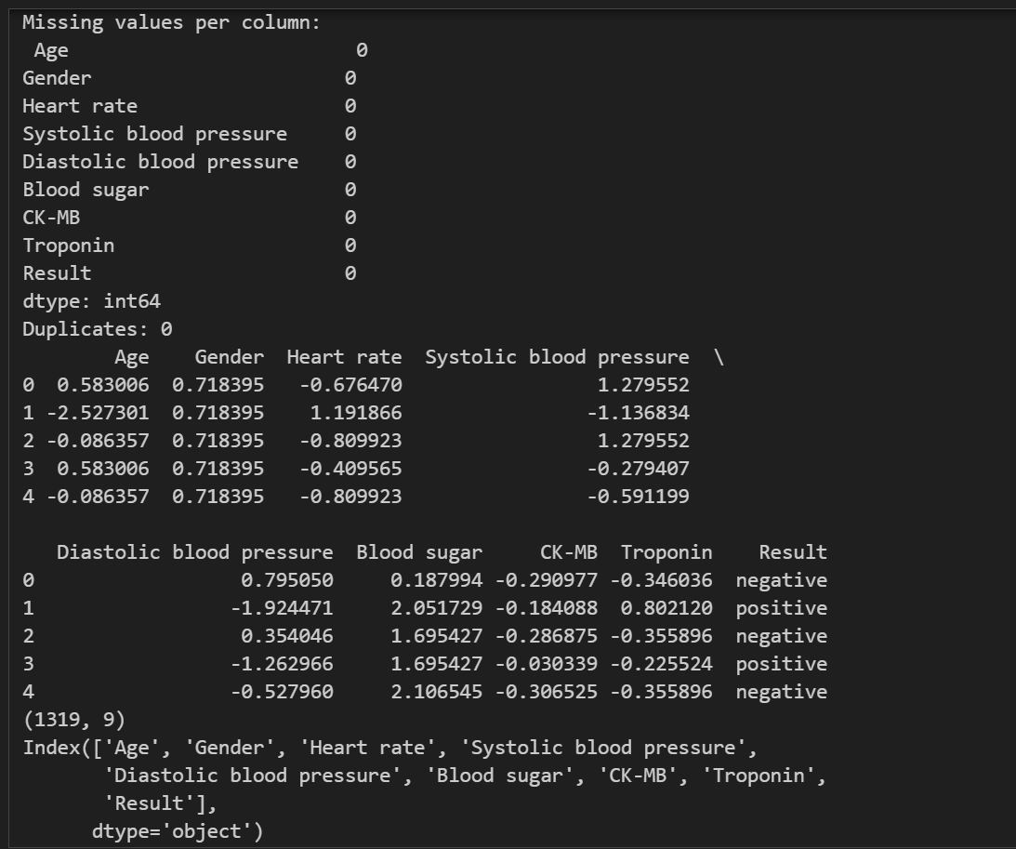
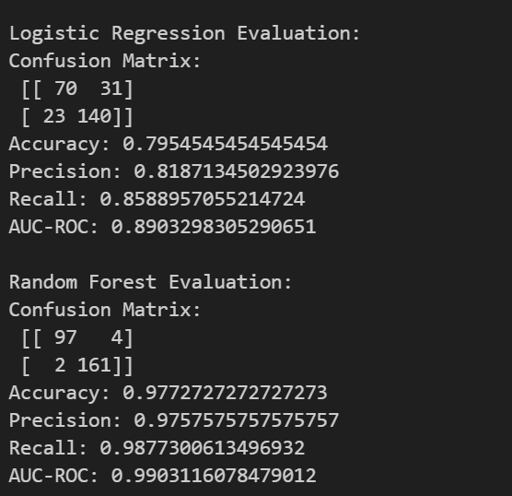
For this project, I used two supervised classification techniques: Logistic Regression and Random Forest. Both are appropriate for predicting a binary outcome (heart attack: yes/no) based on patient features.
Calculations Performed and Outputs
1. Data Preparation:
I handled missing values using mean imputation for numeric columns and the most frequent value for categorical columns.
Outliers were capped at the 1st and 99th percentiles.
All numeric features were normalized using StandardScaler.
The target variable Result was converted to binary (0 for negative, 1 for positive).
2. Correlation Analysis:
I generated a feature correlation matrix using a heatmap to visualize relationships between variables. This helped identify which features were most strongly associated with heart attack outcomes. For example, Troponin and CK-MB showed moderate positive correlations with the target.
3. Model Training and Evaluation:

The data was split into training and test sets (80/20 split).
Logistic Regression and Random Forest models were trained on the training set.
For both models, I calculated:
Confusion Matrix (e.g., for Logistic Regression: [[70, 31], [23, 140]])
Accuracy (Logistic Regression: 0.80, Random Forest: 0.98)
Precision (Logistic Regression: 0.82, Random Forest: 0.98)
Recall (Logistic Regression: 0.86, Random Forest: 0.99)
AUC-ROC (Logistic Regression: 0.89, Random Forest: 0.99)
I also plotted ROC curves to visually compare model performance.
Justification for Analysis Techniques
Logistic Regression:
Why chosen: It is a simple, interpretable model that provides probability estimates and is widely used for binary classification.
Advantage: Easy to interpret and understand feature importance.
Disadvantage: Assumes a linear relationship between features and the log-odds of the outcome, which may not capture complex patterns.
Random Forest:
Why chosen: It is a robust ensemble method that can model complex, nonlinear relationships and is less sensitive to outliers.
Advantage: High accuracy and can capture nonlinear interactions between features.
Disadvantage: Less interpretable than logistic regression and can require more computational resources.
Data Summary and Implications
E. Summarize the implications of your data analysis by discussing the results of your data analysis in the context of the research question, including one limitation of your analysis. Within the context of your research question, recommend a course of action based on your results. Then propose two directions or approaches for future study of the dataset.
Both models performed well, but the random forest classifier achieved higher accuracy (0.98) and AUC-ROC (0.99), indicating excellent predictive performance. Logistic regression also performed strongly, with an accuracy of 0.80 and AUC-ROC of 0.89. This suggests that demographic and health-related attributes can be used to predict heart attack risk with high reliability.
The dataset is from a single hospital and may not generalize to other populations or healthcare settings. Additionally, the random forest model, while accurate, is less interpretable, which may limit its clinical adoption.
Based on these results, clinicians could use similar models as decision-support tools to identify high-risk patients for early intervention. However, further validation on diverse datasets is recommended before clinical deployment.
External Validation: Test the model on data from other hospitals or regions to assess generalizability.
Feature Expansion: Incorporate additional clinical variables (cholesterol, family history) or use advanced models (XGBoost, neural networks) to potentially improve performance.
F. Acknowledge sources, using in-text citations and references, for content that is quoted, paraphrased, or summarized.
No sources were used
G. Demonstrate professional communication in the content and presentation of your submission.

